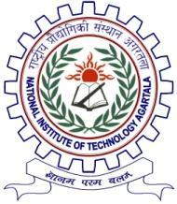

|  |  |
| --- | --- |
| **Department of Computer Science and Engineering** | संगणक विज्ञान अभियांत्रिकी |

|  |  |
| --- | --- |
|  | Date: 18-03-2024 |

**BONAFIDE CERTIFICATE**

**TO WHOM IT MAY CONCERN**

This is to certify that, **Mr. Pranjit Roy** son of Mr. Tapan Roy bearing Enrollment no. 21UCS075, currently a student of 6th Semester BACHELOR OF TECHNOLOGY Computer Science and Engineering Department NIT AGARTALA.

This certificate is issued for the purpose of applying for Summer Internship Programme /Industrial Training 2024 in NIC Agartala.

I wish him every success in life.

